The project shown below is a group-based assignment which I had done with my group members when I am pursuing and studied on UTAR. This is a shoe web site which allow user to buy shoes.

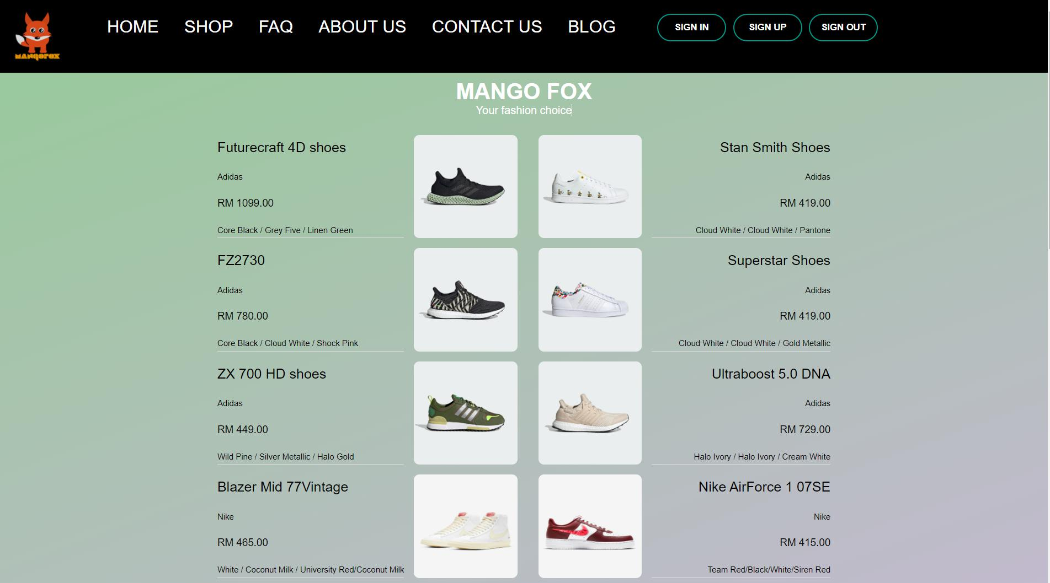

Figure 1: Homepage

This is the Hompage of our website.



Figure 2: Sign Up

This is the sign in interface when user click sign up button at homepage.



Figure 3: Log In

This is the log in interface when user click sign in button at homepage.

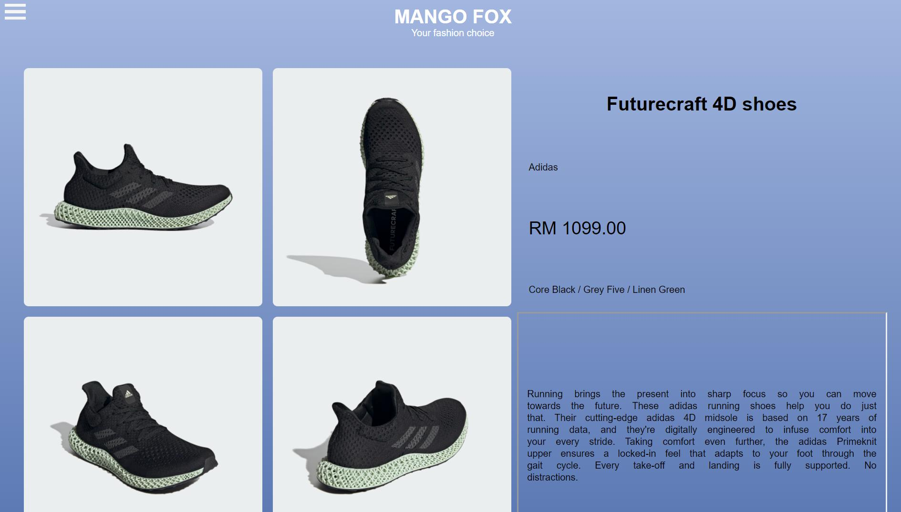

Figure 4: Shoe details

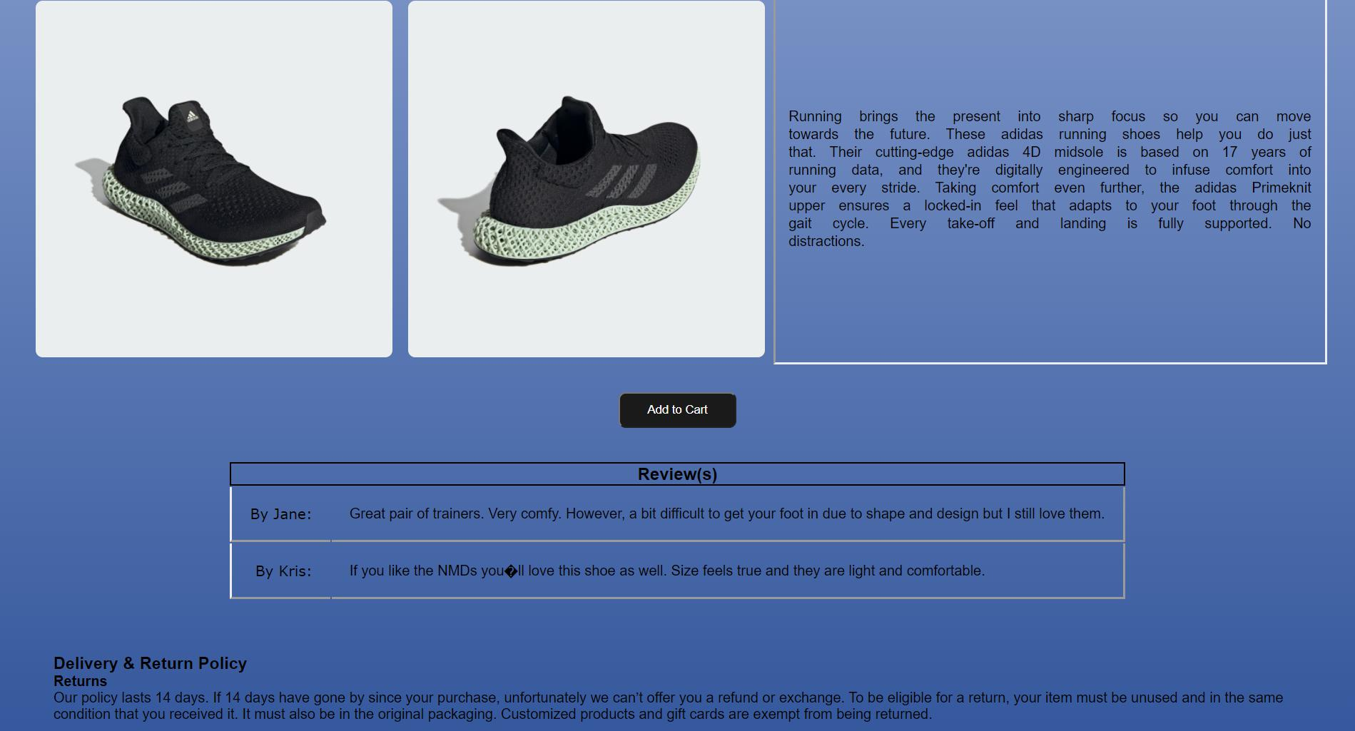

Figure 4.1: Shoe detail

After sign in, user will direct back to homepage and user can select any of the shoes from the homepage. After clicking the show image, it will show all the shoe details and add to chart button.

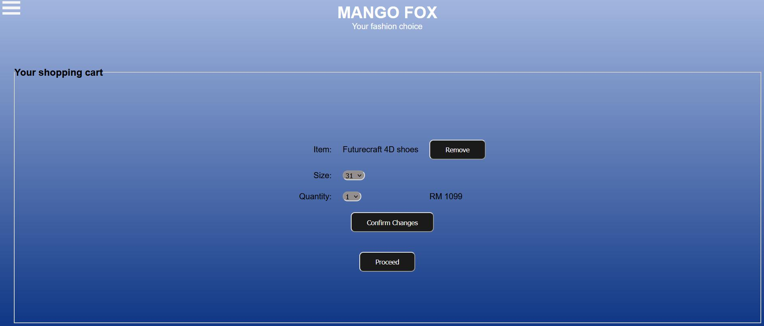

Figure 5: Add to chart

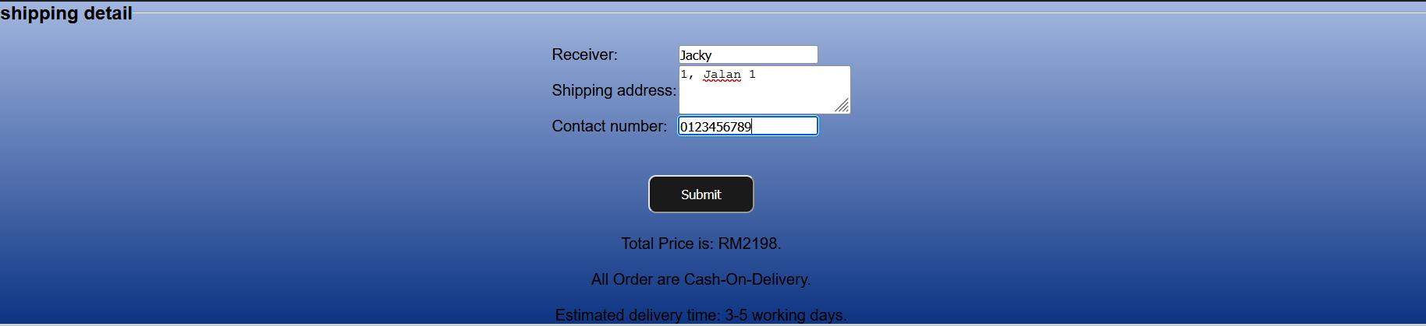

Figure 5.1: Add to chart

After user clicking add to chart button, the interface will be shown as figure 5. User can decide the size, quantity of shoe. User will also need to fill in their information. The interface will also show the total price.

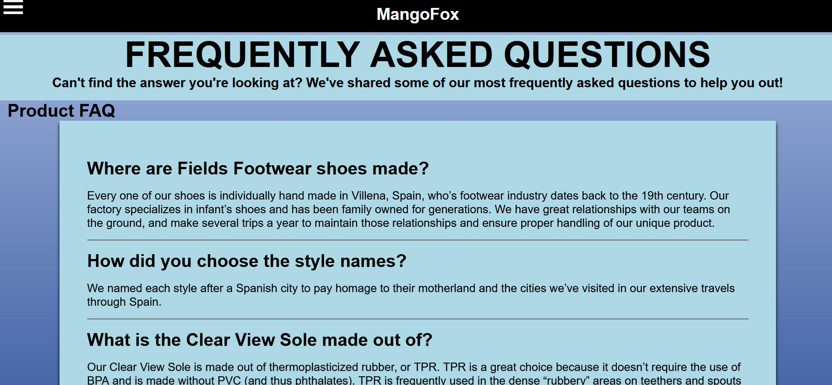

Figure 6: FAQ

Figure 6 show the FAQ interface.

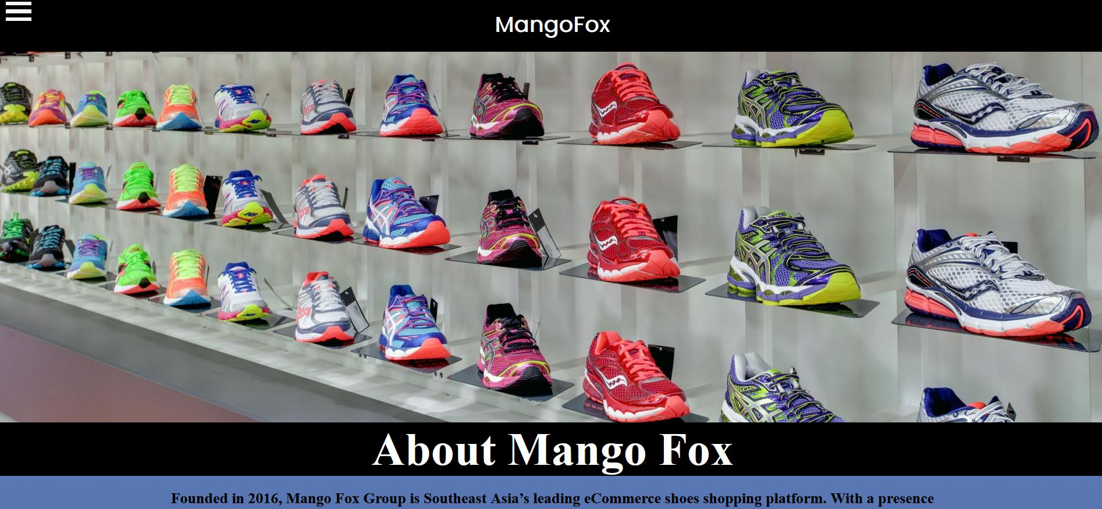

Figure 7: About Us



Figure 7.1: About Us

Figure 7 and 7.1 show the about us interface.

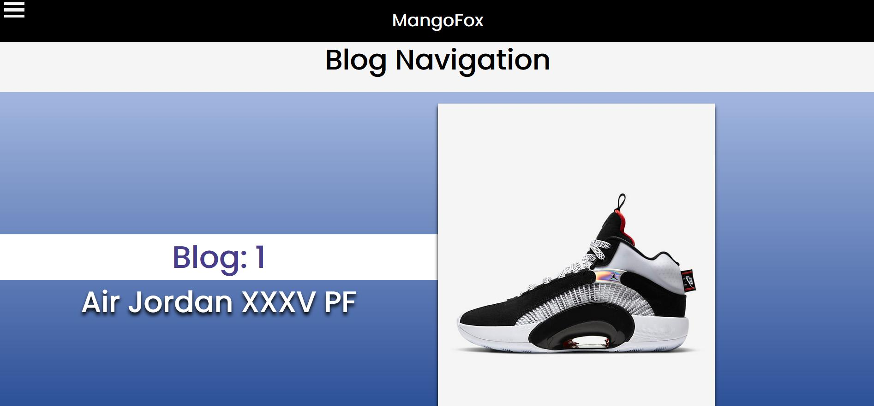

Figure 8: Blog Navigation

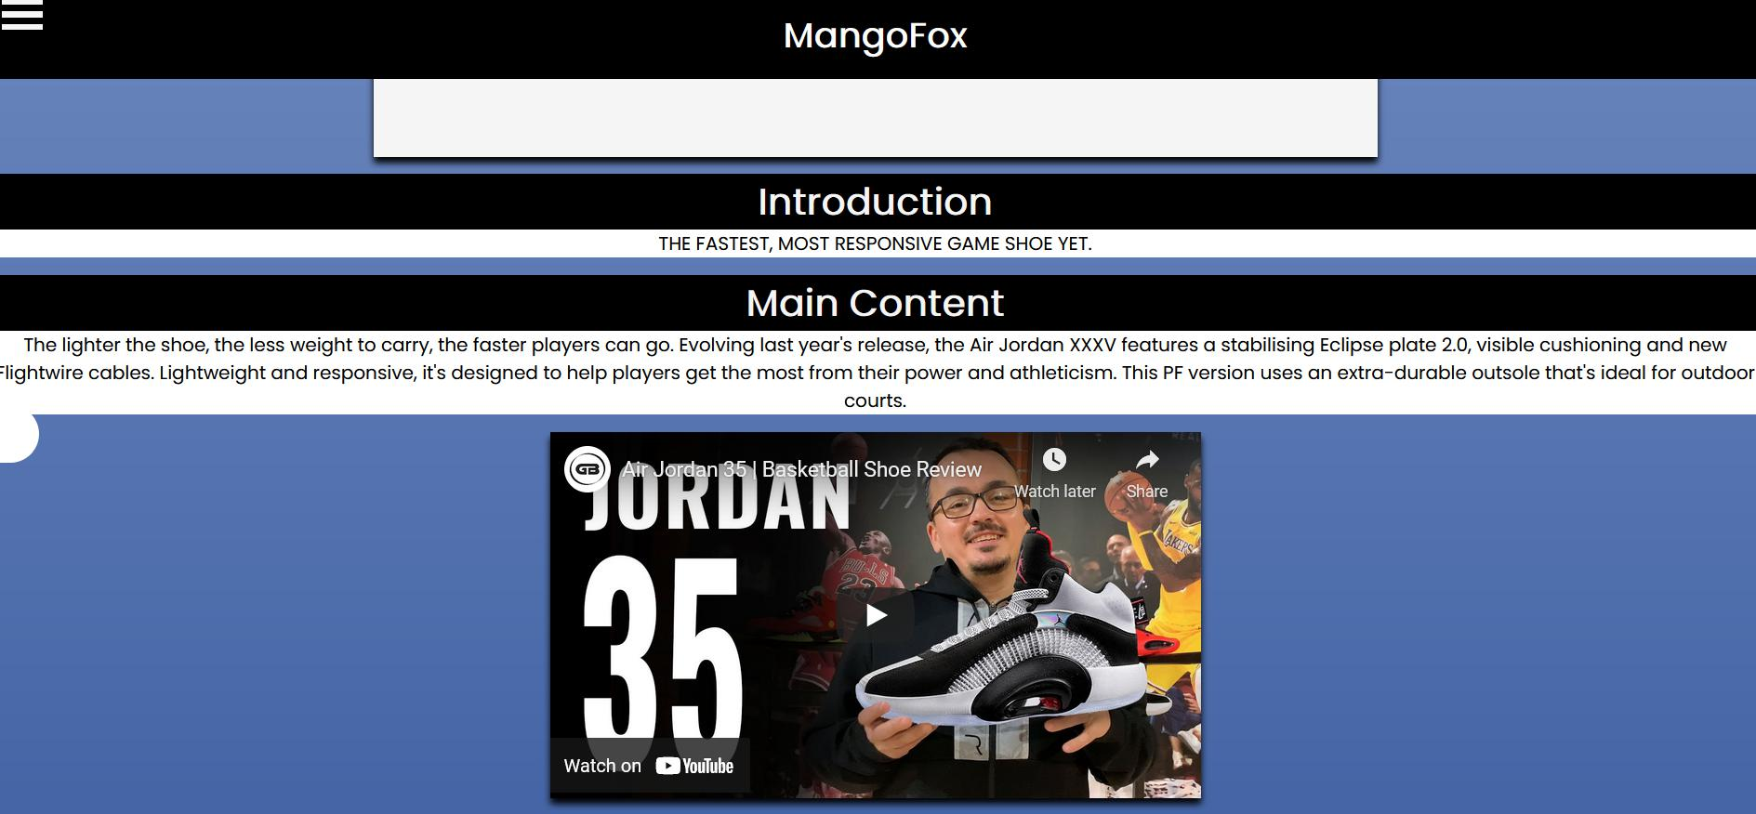

Figure 8.1: Blog

Figure 8 will show all the blogs that are from different type of shoes. Figure 8.1 show blog of the selected shoe.